ABM Pilot Design Framework

Goal Setting

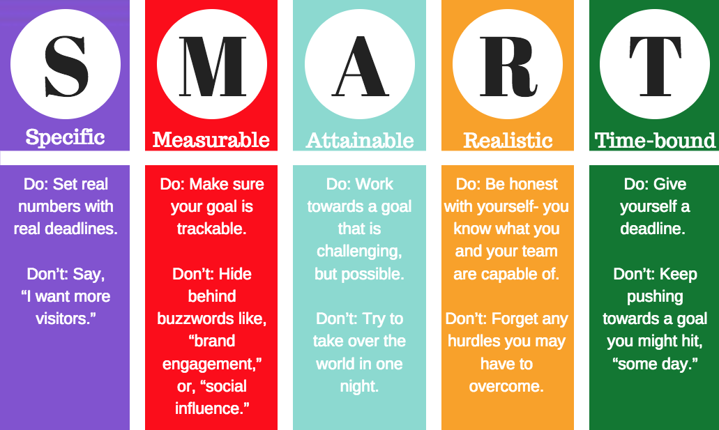

Specific | (why is this important now)
Measurable | (how will you know if this was successful?)
Attainable and  Realistic | (be realistic and can you get buy-in to this?)
Timebound | 90-days

External Barriers | Internal Barriers

Insights

Best Fit Account Research

What do you wish you knew that would help you determine best fit accounts and targets?
[Complete this]

What additional data and insights would help you narrow down your best fit accounts?
[Highlight]

- Firmographic
  - Geography
  - Employees
  - Revenue
  - Market Segment
  - Technology

- Additional characteristics
  - Organization size is a good fit
  - In the right geography
  - Revenue potential is high
  - Sales cycles are shorter than average
  - Aligned with company objectives
  - Financial viability
  - Ability to sell to them
  - Relationships
  - Competitors
  - Stability
  - Third-party relationships

- Sales History
  - Lead
  - Lapsed Opp
  - Live Opp
  - Customer
  - Loyal Customer
  - Lapsed Customer
- Positioning
  - Competitor’s Customer
  - Frequent web site visitors
  - Handraiser
- Intent
  - Intent to buy
  - Interest in category
  - Actively researching
  - Competitor’s customer
  - Persona match

What data and insights would help you determine who is in-market?
[Highlight]

- Sales History
  - Lead
  - Lapsed Opp
  - Live Opp
  - Customer
  - Loyal Customer
  - Lapsed Customer
- Positioning
  - Competitor’s Customer
  - Frequent web site visitors
  - Handraiser
- Intent
  - Intent to buy
  - Interest in category
  - Actively researching
  - Competitor’s customer
  - Persona match

90-day ABM Pilot Design

Complete highlighted elements now and the rest later

Goal (from Exercise #1)
Who will be involved in this project?
Sales:
Marketing:
Other:
Executive sponsor:
Which flavor ABM will you focus on?
1:1
1:Few
1Many
How many accounts do you want to engage in this experiment?
What data and insights are critical for you to gain for this pilot to be successful?
Which persona will you target? What are you trying to achieve with this persona?
What assets do you have to hand to achieve this?
Content:
Data:
Events:
Is there anything new you know you will need?

What technology do you have now that you can implement this with?
Web analytics? CRM? Email analytics?
What else?
Is there anything else that is a must have that will require additional budget?
Why is this critical?
How will you measure success?
What budget is needed?

